Agent Based Modelling for simulating the Interregional Patient Mobility in Italy

Fabrizio PECORAROa,[1], Filippo ACCORDINOa, Federico CECCONIb and Mario PAOLUCCIa,b

a IRPPS-CNR

b ISTC-CNR

ORCiD ID: Fabrizio Pecoraro <https://orcid.org/0000-0001-5718-4240>

**Abstract.** Abstract goes here.

**Keywords.** Patient mobility, Agent-Based Modelling, Italy, Spatial accessibility, Simulation process

# Introduction

Patient mobility is considered as a proxy to appraise the quality and the availability of hospital services [1] and to point out socio-economic disparities at local and regional level [2,3]. This is particularly evident considering surgery for elective treatments where patient tend more frequently to travel long distances to access to care [4,5]. Different studies have underlined the main factors influencing patient mobility [1], including social, demographic and economic status [6], quality and complexity of regional services [7] as well as structural components related to personnel, technologies and equipment available [8]. Among structural components two inter-related aspects seems to be related with patient mobility across regions: accessibility and availability of inter- and extra-regional facilities in particular for patients living at the regional borders [9]. In Italy, the mitigation of this complex phenomenon it was one of the main action at the basis of the Health Pact 2019–2021 signed by the Conference of Regions and Autonomous Provinces. This document highlights the necessity of mapping the flows by type of service, identifying the correspondence with situations regarding lack of supply and drawing up a “plan to stop” passive mobility, with particular attention on critical sectors [1]. For a better understanding of this phenomenon and for capturing which are the main factors influencing patient’s choice, it is necessary to define a behavioral model that includes a variety of individual, community and socio-economic characteristics that represent the patient-system interaction. In different complex settings among which healthcare, this interaction is modelled adopting Agent-Based Modelling (ABM) approach [10]. ABM is able not only to determine which are the main characteristics that rule this interaction and synthesize prior knowledge of a population [11,12], but also to understand how an intervention could modify the dynamics of patient’s behavior and affect public health [13]. This analysis may provide an input for policy makers to capture to what extent capacity, quality and distribution of structures and services may contribute to the reduction of patient passive mobility. Within this context, aim of this study is to design and propose an ABM approach for simulating patient flow across the Italian regions and determining which are the main factors influencing it. The suitability of the proposed approach in this specific setting is tested considering both the accuracy and procession of the simulation process. The application of a robust ABM may provide a new insight into this complex phenomenon by scaling the mathematical model from an abstract (i.e. region, province) to a more refined level (i.e. patient). This makes it possible to significantly describe the interaction of a patient with the health system.

# Materials and methods

## Data collection and identification of factors

Data on hospitals and mobility was gathered from the Ministry of Health website [14] and from the National Outcomes Program website [15], while demographic data was collected from the Italian National Institute of Statistics (ISTAT) website [16]. All data refers to the year 2019. In this study we investigated the hip replacement surgery services, an elective treatment where patients is generally prepared to travel beyond their nearest provider.

To identify which variables mostly impact on patient mobility, we applied the best subsets regression function of R (i.e. *regsubsets*) that tests all possible combinations of the predictor variables and then selects the best model according to the highest adjusted R squared value. The resultant regression model is reported in Equation 1 (note that R2 = 0.66 and all variables are statistically significant, p < 0.05).

${mob}_{\%}=58+0.05w-0.6s-0.06{int }_{intra}+50{ret}_{intra}-0.2{bed}_{intra}$ (1)

where *w* represents the number of days a patient has to wait for accessing the service (at regional level), *s* describes the level of patient’s satisfaction due to the last hospital admission (at regional level), while ${int }_{intra}$, ${ret }_{intra}$ and ${bed }_{intra}$ describe, respectively, the number of interventions, the percentage of patients returned to hospital in the following 2 years after the intervention and the number of beds available in the orthopedics wards. Note that further indicators such as those specifically related to the patient (i.e. income, education) have been discarded from the model as they were not statistically significant. Hospital-related indicators have been computed (for each municipality *i*) adopting the Equation 2 based on a gravity model which relates the increasing probability to access to a hospital with its capacity, quality and distance:

${int}_{intra}^{i}=\sum_{j∈\{Reg\left(i\right)=Reg\left(j\right)\}}{R_{j}w_{i,j}}=\sum_{j∈\{Reg\left(i\right)=Reg\left(j\right)\}}{\frac{{INT}_{j}}{\sum_{i}{{pop}_{i}*w_{i,j}}}}w_{i,j}$ (2)

where $R_{j}$ represents the weighted hospital-to-population index of hospital *j, ${INT}_{j}$* is the number of intervention carried out by hospital *j* and ${pop}_{i}$ is the resident population of the municipality *i*. $w_{i,j}$ that represents the weighting distance between the hospital *j* and the municipality *i* has been computed using the Sigmoid decay function. For each province the ${int}_{intra}$ was computed considering the average value of ${int}_{intra}^{i}$ weighted by population. For further details please see [17].

## Simulation process

Figure 1 shows the main steps of the ABM simulation process. Starting from the whole target population a set of 100000 possible patients are extracted adopting a stratified random sampling methodology to accurately reflects the population under investigation. The sampling procedure considers two risk factors: age and gender. The second step (i.e. simulation) is composed by three activities: 1) a set of 1000 patients are extracted from the sample population to define the group of patients that need to be cared; 2) selected patients and hospitals are placed over the patches of the environment; 3) one patient at time is randomly picked up and the mobility index (see Equation 1) is computed to assess the probability that the patient travels outside the region to be cared.

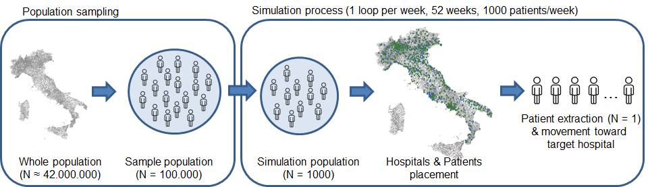

**Figure 1.** Agent-based modelling simulation process

The agent-based modelling simulation process finally determines the hospital chosen by the patient on the basis of the mobility index as well as of the availability and accessibility of the hospitals available over the territory. The simulation process is executed 52 times each one comprising 1000 patients to model the access to care as a weekly procedure considering that the average length of stay for the primary total hip replacement is around 7 days [18]. To capture the accuracy (i.e. reproducibility) and the precision (i.e. repeatability) of the model five sessions of the whole model has been executed. From a statistical perspective, accuracy was assessed using the regression coefficient between the simulated data and the original data, while precision was assessed using the Intraclass Correlation Coefficient (ICC(2,1)) to capture the intra-session reliability between the five observations.

# Results

Figure 2 shows the Netlogo environment showing on the left side the interface items adopted to control agents and the system. In particular, the *n_ticks* and *n_patients* inputs allow to set, respectively, the number of weeks and the number of patients per week to be involved in the simulation. The output *patients_to_be_placed* facilitates the supervision of the status of the process capturing the total number of patients located over the environment that has not been hospitalized yet. As highlighted on the right side of the window the Netlogo environment integrates the representation of the Italian territory divided by municipalities, colored depending on the passive mobility percentage. A specific legend is also reported to easily read how this index is distributed over the territory. Note that the map is updated every tick (i.e. week) of the simulation process.

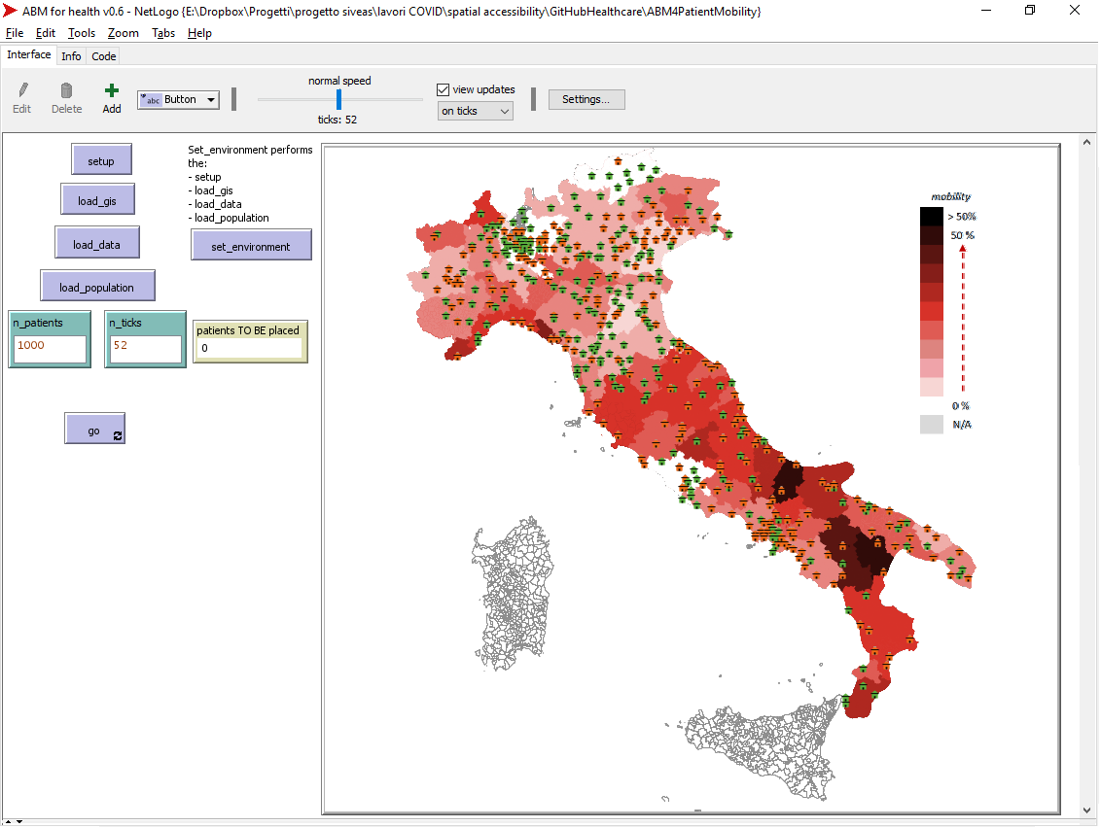

**Figure 2.** Netlogo environment highlighting the preliminary results of one simulation session

The scatterplot diagram reported in Figure 3 highlights the linear regression coefficient and model between the passive mobility gathered from the ABM simulation (x-axis) and the passive mobility computed with the multiple linear regression model (y-axis). As clearly reported by the R-squared (> 0.98), there is a very strong direct relationship between the passive mobility simulated by the proposed model and the passive mobility computed with the multiple linear regression model. A high correlation (R > 0.81) is also present considering the linear regression between the simulation passive mobility and passive mobility computed with the real hospital values. This result confirms the goodness of the simulation model. Considering the precision, the ICC computed carrying out five sessions of ABM simulation resulted higher than 0.95 confirming the repeatability of the process.

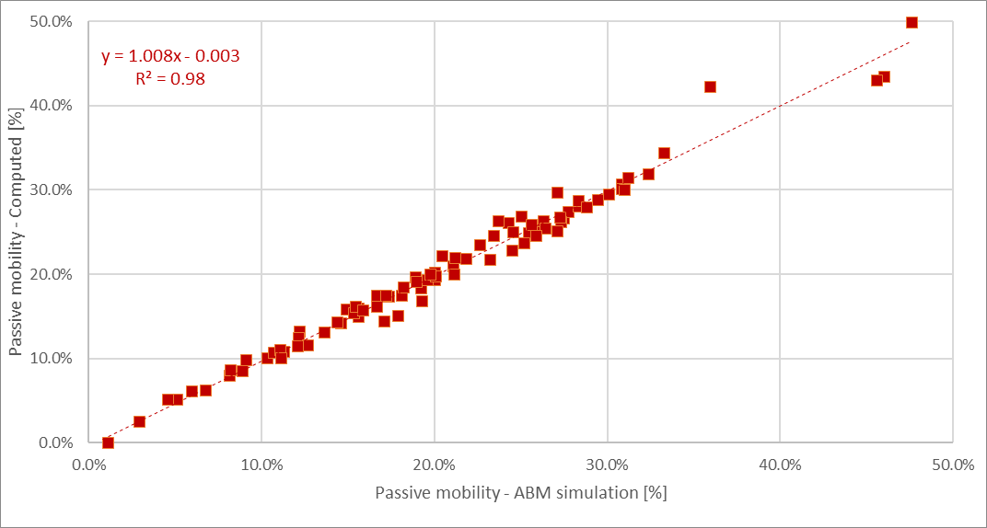

**Figure 3.** Correlation between the passive mobility gathered from the simulation model (x-axis) and the passive mobility computed with the multiple linear regression model (y-axix)

|  |  |  |
| --- | --- | --- |
|  |  |  |

# Discussion and conclusions

Patient mobility is considered one of the main concerns for policy-makers as it impacts financial sustainability of the regional health system affected by the high percentage of patients accessing care services in other regions. Local authorities have stressed the need of identifying the main factors that influence patient’s choice with particular attention on the access to critical services. This makes it necessary to model the patient-environment interaction on the basis of the prior knowledge of a population as well as to determine how an intervention could modify this dynamical model and impact on patient mobility. In this paper we provide an ABM approach that starting from the information gathered at patient, hospital and local level determines the probability that a patient accesses to extra-regional services for a hip transplant surgery procedure. To accomplish this task we firstly defined a mathematical model able to accurately describe the dynamics of the patient-environment interaction. Based on this mathematical model, the ABM approach simulates the access to care for each patient and determines the level of attraction and repulsion that each hospital has with him/her depending on the quality, capacity and distance of health structures located over the territory. Preliminary results to verify the applicability of the ABM approach highlight a high precision and accuracy in the description of patient mobility in accessing healthcare services and structures. This is clearly evident considering the very strong correlation between the simulated and the computed as well as the real passive mobility. Moreover, the repeatability of the process is also confirmed by analyzing the results reported by the different simulations and their variability. This high accuracy and precision of the model confirms the goodness of the ABM simulation approach.

In this paper, we applied this methodology considering the hip replacement surgery procedure. However, this can also be applied to other elective surgery or curative services, to primary care services, to laboratory analysis services, or even to acute care services, such as intensive care. To apply this scalability it is necessary to have a robust mathematical model able to describe the dynamics of the patient-system interaction.

The results reported in this paper only describe the simulation of a real use case based on a prior knowledge of a population limiting the attention on patient passive mobility. Future works aim to further details the mathematical model to determine which are the main factors at local and regional level responsible for attracting patients and contribute to patient’s active mobility. Moreover, simulation basic variables will be modified to verify how these changes may impact on patient mobility. This may help policy makers and hospital administrative professionals to capture to what extent these changes may help patients to remain in their region for accessing healthcare services. For instance this can be done by reducing the waiting times, improving the number of beds available or even providing an additional point of care in a specific part of the region territory that, for instance, is not reached by the service under investigation.

References

1. Nante N, Guarducci G, Lorenzini C, Messina G, Carle F, Carbone S, Urbani A. Inter-Regional Hospital Patients’ Mobility in Italy. Healthcare. 2021; 9(9): 1182.
2. Fattore G, Petrarca G, Torbica A. Traveling for care: Inter-regional mobility for aortic valve substitution in Italy. Health Policy. 2014; 117(1): 90-97.
3. Ricci A, Barzan E, Longo F. How to identify the drivers of patient inter-regional mobility in beveridgean systems? Critical review and assessment matrix for policy design & managerial interventions. Health Services Management Research. 2021; 34(4): 258-268.
4. Berta P, Guerriero C, Levaggi R. Hospitals’ strategic behaviours and patient mobility: Evidence from Italy. Socio-Economic Planning Sciences. 2021: 101030.
5. Pecoraro F, Clemente F, Luzi D. The efficiency in the ordinary hospital bed management in Italy: An in-depth analysis of intensive care unit in the areas affected by COVID-19 before the outbreak. Plos one. 2020; 15(9): e0239249.
6. Mafrolla E, D’Amico E. Patients’ mobility as an indicator for (in)efficiency: a panel data analysis on Italian health care authorities. Health Econ Rev. 2013; 3:3.
7. De Curtis M, Bortolan F, Diliberto D, Villani L. Pediatric interregional healthcare mobility in Italy. Italian Journal of Pediatrics. 2021; 47(1): 1-7.
8. Balia S, Brau R, Marrocu E. Interregional patient mobility in a decentralized healthcare system. Regional Studies. 2018; 52(3): 388-402
9. Pecoraro F, Luzi D, Clemente F. Spatial Inequity in Access to Intensive Care Unit Beds at Regional Level in Italy. Studies in Health Technology and Informatics. 2021; 281: 809-813.
10. REF Agent Based Modelling
11. Volker Grimm, (1999), Ten years of individual-based modelling in ecology: what have we learned and what could we learn in the future?, Ecological Modelling, Volume 115, Issues 2–3, Pages 129-148
12. Steinbacher, M., Raddant, M., Karimi, F. et al. Advances in the agent-based modeling of economic and social behavior. SN Bus Econ 1, 99 (2021). https://doi.org/10.1007/s43546-021-00103-3
13. Marshall B. Agent-based modelling. In: El-Sayed AM, Galea S, editors. Systems science and population health. Oxford: Oxford University Press; 2017. p. 29–51
14. Ministry of Health. National healthcare service database. 2022. Available from: [www.salute.gov.it/portale/documentazione/p6_2_8_1_1.jsp?lingua=italiano&id=6](http://www.salute.gov.it/portale/documentazione/p6_2_8_1_1.jsp?lingua=italiano&id=6)
15. <https://pne.agenas.it/>
16. Italian National Institute of Statistics (ISTAT). Available from: <https://www.istat.it/it/archivio/222527>
17. Pecoraro, F., Luzi, D., & Clemente, F. (2022). The Impact of Hospital Accessibility on Interregional Patient Mobility in Italy. Studies in Health Technology and Informatics, 294, 684-688.
18. Foote, J., Panchoo, K., Blair, P., & Bannister, G. (2009). Length of stay following primary total hip replacement. The Annals of The Royal College of Surgeons of England, 91(6), 500-504.

SCARTI

Petitti DB, Crooks VC, Buckwalter JG, Chiu V. Blood pressure levels before dementia. Arch Neurol. 2005 Jan;62(1):112-6, doi: ....

Rice AS, Farquhar-Smith WP, Bridges D, Brooks JW. Canabinoids and pain. In: Dostorovsky JO, Carr DB, Koltzenburg M, editors. Proceedings of the 10th World Congress on Pain; 2002 Aug 17-22; San Diego, CA. Seattle (WA): IASP Press; c2003. p. 437-68. doi: ....

1. https://www.ncbi.nlm.nih.gov/pmc/articles/PMC8466093/
2. https://www.annualreviews.org/doi/10.1146/annurev-publhealth-040617-014317
3. impact of hospital accessibility on Interregional Patient Mobility in Italy (see https://ebooks.iospress.nl/doi/10.3233/SHTI220556).

## Heading

First paragraph.

* Item
* Item
* Item

Second paragraph.



**Figure 1.** Short caption.

**Table 1.** Long caption. Long caption. Long caption. Long caption. Long caption. Long caption. Long caption. Long caption. Long caption

|  |  |  |
| --- | --- | --- |
| **Column1** | **Column2** | **Column3** |
| –10.2 | 10.2 | 10.2 |
| 5.36 | 6.32 | 6.32 |
| –5.7 | 5.7 | 0.326 |

 (1)



$mob=0.58+5{∙10}^{-4}wait-6∙{10}^{-3}sat-6∙{10}^{-4}{int }_{intra}+0.5{ret}_{intra}-2∙{10}^{-3}{bed}_{intra}$

The regression model to capture which are the variables that mostly impact on patient mobility. environment/regional system (i.e. waiting time to access to care, patient satisfaction on hospital services) and hospital accessibility in terms of number of beds available for orthopedics services (i.e. structure indicator) interventions performed (i.e. process indicator), rate of patients returned to the hospital for after-surgery issues (i.e. outcome indicator). Usually these indicators consider only the availability of regional resources, neglecting two fundamental aspects of universal care: the accessibility in terms of travel distance and the availability of extra-regional facilities in particular for patients living at the regional borders [9]. For this reason in this study the resources available for each patient are computed considering the accessibility index proposed in [X] and adopted by our research group in previous studies [e.g. X].

1. Fabrizio Pecoraro, IRPPS-CNR, Via Palestro, 32, 00185 Rome, Italy (f.pecoraro@irpps.cnr.it)